|  |
| --- |
| **Kafka Installation and implementation** |

Download required files from below location

Zookeeper : <http://zookeeper.apache.org/releases.html>

Kafka : <http://kafka.apache.org/downloads.html>

**Installation:**

**Java**

1. Install JAVA and set the environment variable JAVA_HOME

**Zookeeper**

1. Goto your zookeeper config directory. E.g. C:\zookeeper-3.3.6\conf
2. Rename file “zoo_sample.cfg” to “zoo.cfg”
3. Open zoo.cfg in any text editor
4. Find and edit dataDir = /tmp/zookeeper to dataDir = C:\zookeeper-3.3.6\Data
5. Add entry in system env variables as we did for java
   1. Add system variable ZOOKEEPER_HOME = C:\zookeeper-3.3.6
   2. Add system variable path as C:\zookeeper-3.3.6\bin

**Kafka**

1. Goto your kafka config directory. E.g. C:\kafka_2.12-1.0.0\config
2. Edit file “Server.Properties”
3. Find and edit line “log.dirs=/tmp/kafka-logs” and change it to “log.dir = C:\kafka_2.12-1.0.0\kafka-logs”
4. If your Zookeeper is running on some other machine or cluster you can edit “zookeeper.connect:2181” to your custom IP and port.
5. Your Kafka will run on default port 9092 & connect to zookeeper’s default port which is 2181.

**Running the instances**

**Zookeeper**

1. Open a new cmd and type zkserver and press enter. You will see the screen like below.

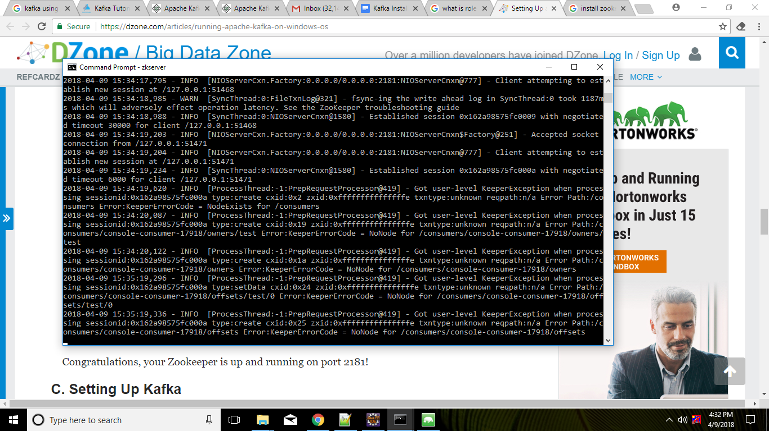

**Kafka**

Please ensure that your zookeeper instance is up and running before running kafka

1. Goto your kafka installation directory and open command prompt by pressing Shift + Right click.
2. Now type .\bin\windows\kafka-server-start.bat .\config\server.properties
3. If everything is fine you will see a screen like below image.

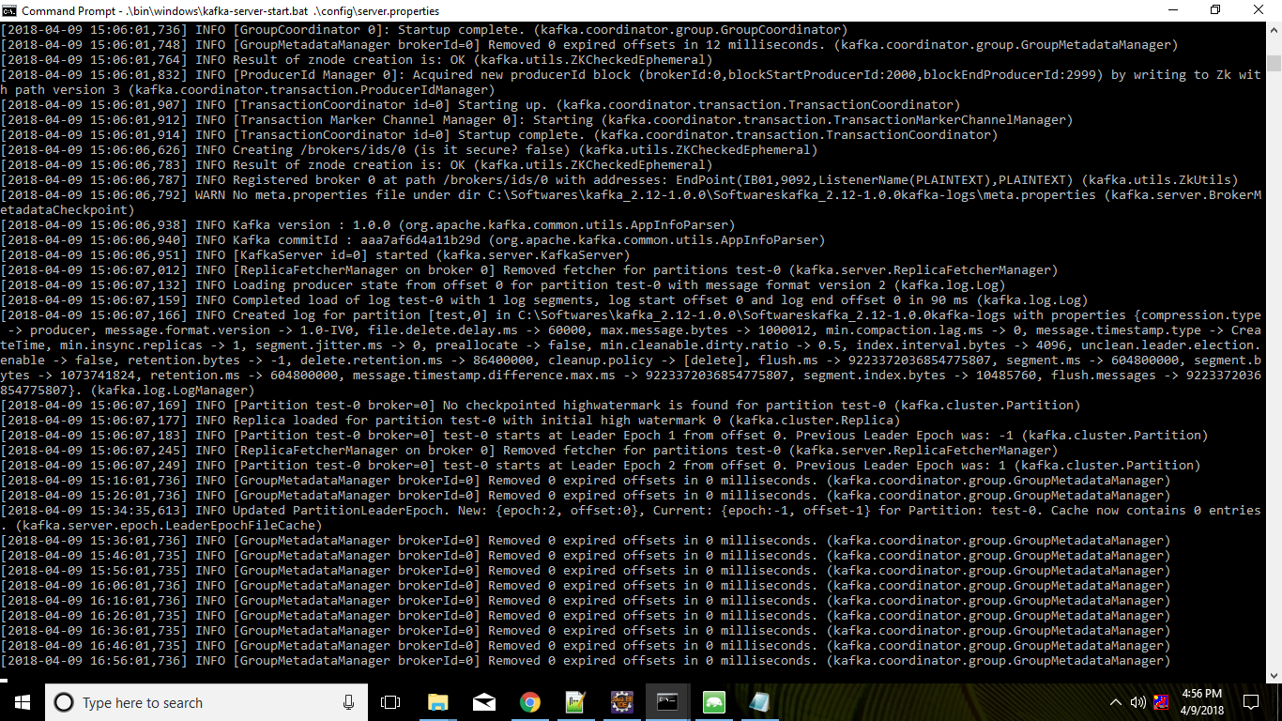

**Creating kafka topic**

1. Now create a topic with name “test” and replication factor 1, as we have only one Kafka server running. If you have a cluster with more than 1 Kafka server running, you can increase the replication-factor accordingly which will increase the data availability and act like a fault-tolerant system
2. Open a command prompt in the location C:\kafka_2.12-1.0.0\bin\windows
3. Type following command and hit enter

|  |
| --- |
| kafka-topics.bat --create --zookeeper localhost:2181 --replication-factor 1 --partitions 1 --topic test |

**Create producer and consumer**

1. Open a command prompt in the location C:\kafka_2.12-1.0.0\bin\windows
2. Type below command and hit enter.

|  |
| --- |
| kafka-console-producer.bat --broker-list localhost:9092 --topic test |

1. Again open a command prompt in the location C:\kafka_2.12-1.0.0\bin\windows
2. Type below command and hit enter.

|  |
| --- |
| kafka-console-consumer.bat --zookeeper localhost:2181 --topic test |